Goro Kakei
Dates: Feb 25 – Mar 25, 2023
Location: Taka Ishii Gallery (complex665)

Taka Ishii Gallery is pleased to present a solo exhibition of the work of Goro Kakei from Saturday, February 25 to Saturday, March 25. Kakei is known as a postwar Japanese sculptor who, from the 1950s onward, prolifically produced sculptures, oil paintings, drawings, etchings, and lithographs using a wide range of media and techniques. This solo show, Kakei’s first at Taka Ishii Gallery, will feature sculptures and oil paintings created from the 1970s to the 2000s, selected from among the vast body of work that he continued to produce until his final years.

In 1949, during the chaotic postwar era, Kakei moved from Shizuoka to Tokyo, where he encountered the sculpture of Yoshi Kinouchi. He later recalled that “it was the beginning of my life,” and this encounter marked the start of Kakei’s sculptural career. The following year Kakei enrolled in the Department of Sculpture at Tokyo University of the Arts, where he began to pursue sculpture seriously. Not content with academic techniques, he gradually began exploring his own unique expression of the human figure, introducing bold deformation through direct application of plaster.

In 1957 he submitted “The Annunciation” to the 21st Exhibition of the Shinseisaku Art Society and received the New Artist Award, and he subsequently produced many works based on his Christian faith, including “The Virgin Mary” (1958), “Job” (1961) and “Apostle” (1962). For Kakei, who was baptized at the age of 18, creating art derived from the Bible was not only a means of interpreting the sacred text, but also a practice of pursuing his own speculations on the nature of human existence. In the 1960s, when diversification of materials and young artists’ unfettered modes of expression were on the rise, Kakei did not follow new developments in contemporary art, but instead continued to pursue his own unique figurative style by focusing on the classic motif of the human figure.

If you look at Cezanne’s monumental “The Bathers”, the human figures are intentionally deformed in a way that seems almost awkward, resulting in a landscape that encompasses both nature and humankind. Humankind is the basis of everything. Without drawing people, it is impossible to understand nature.
From “At Work Kakei”, Yobi-sha, 2009

On the occasion of his participation in the 8th São Paulo Biennial in 1965, Kakei traveled to the United States, Trinidad and Tobago, Brazil, and Mexico. He was particularly drawn to Mexican sculpture, and in 1968 he went to Mexico to teach at a university for two years. After returning from Mexico, Kakei’s rendering of the human figure showed formal simplification due to changes in his perceptions of depiction of the body, and the primitivist atmosphere of his earlier works faded while he gradually moved away from Christian motifs. It is evident that Kakei’s sculptural sensibilities changed as a result of his exposure to Mexican culture and woodcarving. From the 1970s onward he continued to make many outdoor sculptures that emphasized the volumes of the body, but in 1984 and 1985 he produced the “Human Issues series”, which is characterized by well-balanced, elongated bodies with greatly stretched limbs and a reduction of the masses seen in his earlier works.

Following the death of his beloved mother Chau, whom he depicted numerous times in his work, and his own long battle with serious illness, Kakei’s art from the 1990s onward incorporated a richer sense of humanity and humor. Even in the final years of his 70-year career, he never stopped creating highly original works that defy conventional concepts of art.

Kakei’s main solo exhibitions include “The World of Goro Kakei’s Sculpture,” Contemporary Sculpture Center, Tokyo & Osaka (1984); “Kita Ni, Higashi Ni,” Asahikawa Museum of Sculpture in Honor of Teijiro Nakahara, Hokkaido (1999); and “Goro Kakei: Natsu no Mori,” Oikawa Museum of Art, Gunma (2011). He participated in such group exhibitions as “History of Modern Sculpture of Japan: From Photographic Expression to Three-Dimensional Objects,” The Museum of Modern Art, Ibaraki (1991) which traveled to the Tokushima Modern Art Museum (1991); “New Generation of Japanese Sculptors,” The National Museum of Modern Art, Tokyo (1963); “STORIES,” Shizuoka Prefectural Museum of Art, Shizuoka (2021). He is the recipient of many awards, including the 7th Teijiro Nakahara Sculpture Prize Excellence Award (1976) and the 7th Exhibition of Contemporary Japanese Sculpture Kobe Suma Rikyu Park Award (1977). In 1981 he received the National Museum of Modern Art, Tokyo Award and the Museum of Modern Art, Kamakura & Hayama Award at the 9th Exhibition of Contemporary Japanese Sculpture, as well as the Excellence Award at the 2nd Exhibition of Kotaro Takamura Prize. Kakei was also the recipient of the 23rd Nakahara Teijiro Award in 1992.

For further information, please contact:
Exhibition: Akane Kenmoku / Press: Masayo Suzaki (press@takaishiigallery.com)
6-5-24 3F Roppongi Minato-ku Tokyo 106-0032 tel: +81 (0)3 6434 7010 fax: +81 (0)3 6434 7011
e-mail: tig@takaishiigallery.com website: www.takaishiigallery.com
Tue-Sat 12:00 – 19:00 Closed on Sun, Mon, and National Holidays
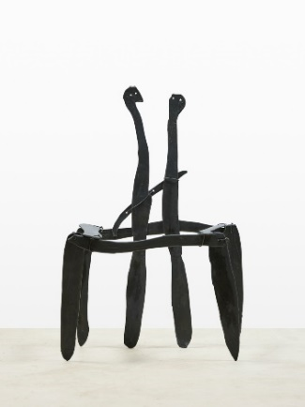 | Goro Kakei  “Area-Ⅱ”, 1991  Bronze  95 x 58 x 52 cm
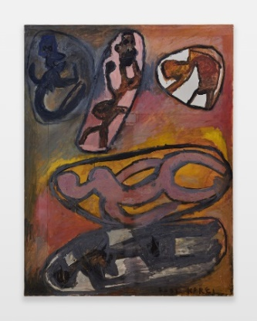 | Goro Kakei  “Untitled”, 2001  Oil on canvas  145.5 x 112 cm

